MODULE 4 – INTRODUCTION TO DBMS

LAB EXERCISES

14. SQL View
Lab 1.
Create a view to show all employees along with their department names.
Ans.
1. CREATE VIEW employee_department_view AS
SELECT employees.emp_name, department.dept_name
FROM employees INNER JOIN department ON employees.dept_id = department.dept_id;

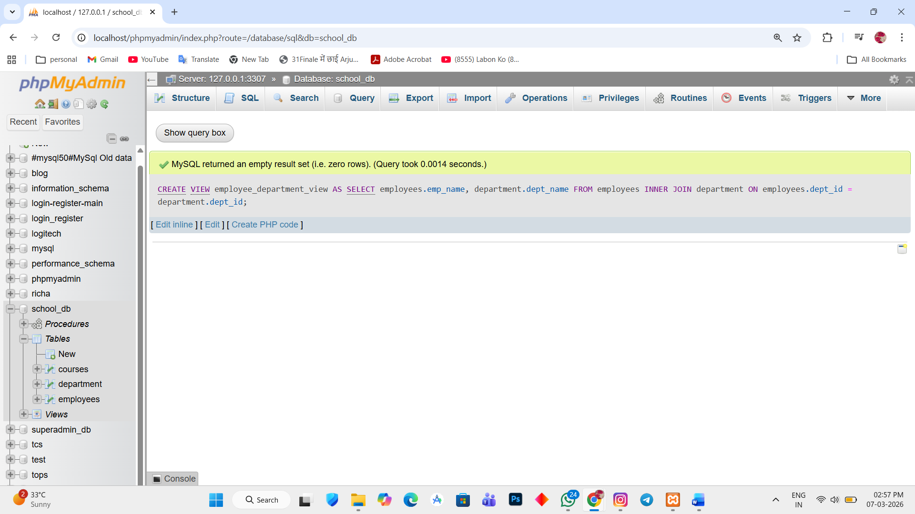
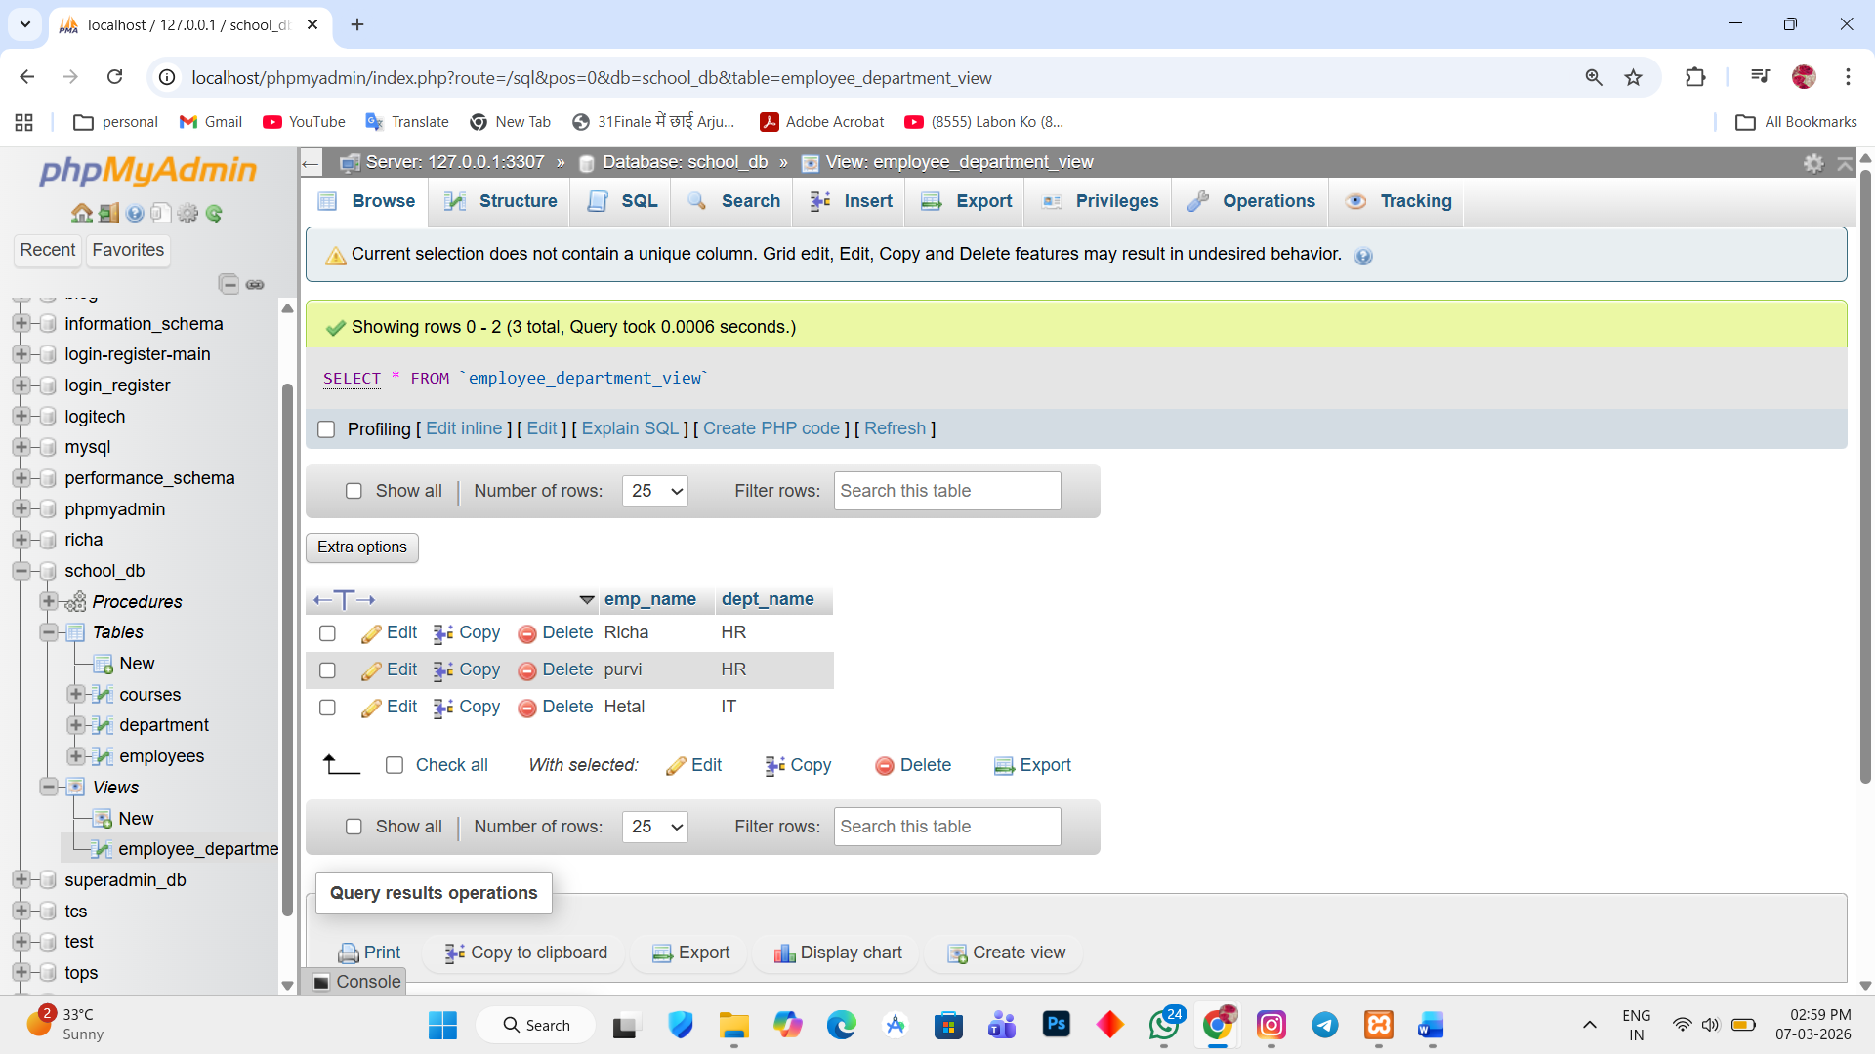

Lab 2.
Modify the view to exclude employees whose salaries below $50,000.
Ans.
1. INSERT INTO employees(emp_name, salary) VALUES ('Harsha', '50000'),('Yash','120000'), ('Jatin','55000'), ('Hardik', '60000'), ('Yansh', '70000');
2. CREATE OR REPLACE VIEW employee_department_view AS
SELECT employees.emp_name, department.dept_name, employees.salary FROM employees
INNER JOIN department ON employees.dept_id = department.dept_id WHERE employees.salary >= 50000;

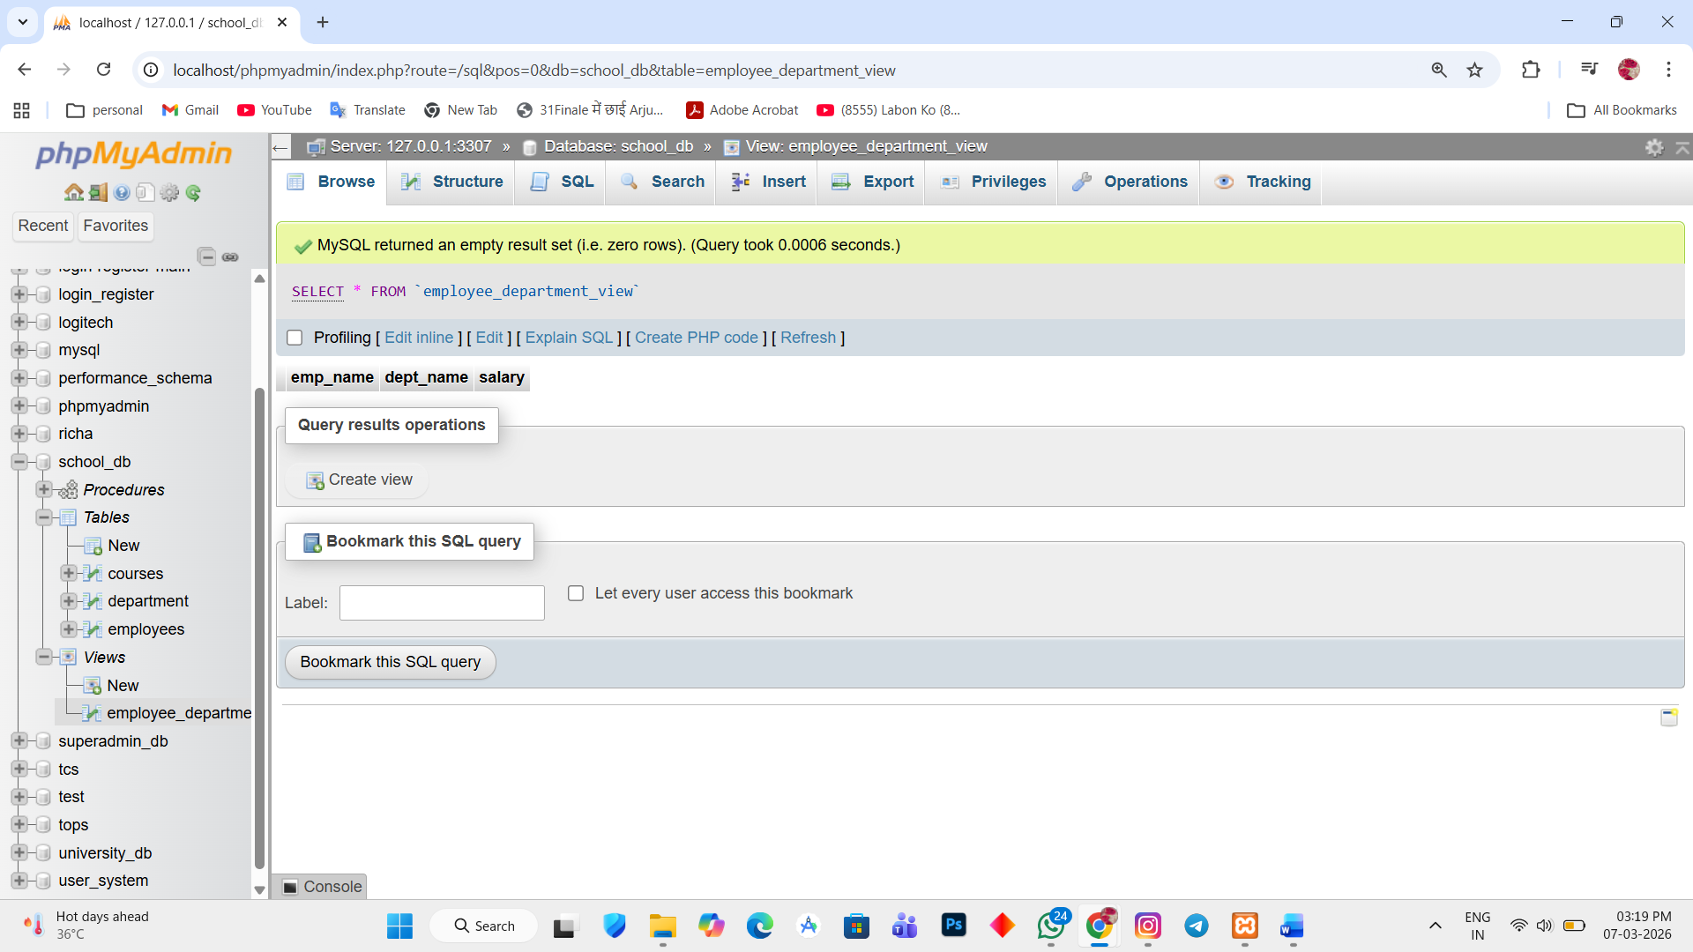

UPDATE employees SET dept_id = 2 WHERE emp_name = 'Harsha';
UPDATE employees SET dept_id = 3 WHERE emp_name = 'Yash';
UPDATE employees SET dept_id = 4 WHERE emp_name = 'Jatin';
UPDATE employees SET dept_id = 5 WHERE emp_name = 'Hardik';
UPDATE employees SET dept_id = 6 WHERE emp_name = 'Yansh';

